Member Number: ____________________
Time: ___________________
Rank: _______________



FUNDAMENTALS OF
WEB DESIGN
(415)

National 2024

Objective Questions (25 x 2pt) _________________ (50 points)
HTML/CSS Coding _________________ (350 points)

TOTAL POINTS _________________ (400 points)

INDUSTRY CERTIFICATION (50 minutes)
IT Specialist HTML and CSS Certification

Test Time: 90 minutes
GENERAL GUIDELINES:
Failure to adhere to any of the following rules will result in disqualification:
- No equipment, supplies, or materials other than those specified for this event are allowed in the testing area. No previous BPA tests and/or sample tests (handwritten, photocopied, or keyed) are allowed in the testing area.
- Electronic devices will be monitored according to ACT standards.

PART ONE Instructions: Concept Knowledge

1. Open Google Chrome and navigate to compete.bpa.org.
2. Click on the appropriate Division (Secondary or Post-Secondary) Competitions button.
3. Enter your BPA Member ID (8-digits) and Password to access your test questions.
4. Answer all questions and submit your test.
5. Move on to Part Two.

PART TWO Instructions: Production
1. No equipment, supplies, or materials other than those specified for this event are allowed in the testing area. No previous BPA tests and/or sample tests (handwritten, photocopied, or keyed) are allowed in the testing area.
2. Once you have completed all four jobs listed below, upload all competition materials (including project files, etc.) to the National BPA Pre-submit System at presubmit.bpa.org.
3. Compress all files in a single archive (zip file) and use the following:

FWD-MemberID.zip

PART THREE Instructions: Industry Certification
This exam requires the IT Specialist HTML and CSS Certification. Please do not leave your seat or exit the room until you have completed the certification. After the certification has been administered, you are permitted to leave.

The task is to design a multi-page website celebrating global cuisines.

Pages:
- Home (Index) Page:
  - Body Content:
  - Header:
    - Include a navigation menu linking to other pages: Home, Recipes, and Contact Us.
        - Background Color: #333
        - Text Color: #fff
        - Centered
  - Section:
    - It should feature a two-column layout with an image of ingredients on the left column (right-justified) and a welcoming message on the right column (left-justified).
    - Left column image: ingredients.jpg
    - Right column text:

Embark on a culinary journey around the world with us and explore the rich diversity of global cuisines. From tantalizing appetizers to mouthwatering desserts, our blog is your passport to discovering new flavors, learning culinary techniques, and celebrating food cultures from every corner of the globe.
    - Footer:
      - Include the following text:

Follow us on social media for more recipes and stories.
      - Background Color: #333
      - Text Color: #fff

- Recipes Page:
  - Body Content:
  - Header:
    - Include a navigation menu linking to other pages: Home, Recipes, and Contact Us.
        - Background Color: #333
        - Text Color: #fff
        - Centered
  - Section:
    - It should feature a three-column layout (evenly distributed)
    - Left column
(Bold, H2): Authentic Margherita Pizza
(Image 75% width of column): pizza.jpg
(Bulleted List) Ingredients:
- Fresh tomatoes
- Mozzarella cheese
- Fresh basil leaves
- Olive oil
- Salt and pepper
- Pizza dough
(Ordered List) Instructions:
- Preheat the oven to 475°F (245°C).
- Roll out the pizza dough on a floured surface.
- Spread olive oil on the dough, then add sliced tomatoes, mozzarella cheese, and basil leaves.
- Season with salt and pepper.
- Bake in the preheated oven for 10-12 minutes, or until the crust is golden brown and the cheese is melted and bubbly.
- Remove from oven, slice, and serve hot.
    - Middle column
(Bold, H2): Classic French Ratatouille
(Image 75% width of column): ratatouille.jpg
Ingredients (Coming Soon):
    - Right column
(Bold, H2): Spicy Thai Green Curry
(Image 75% width of column): curry.jpg
Ingredients (Coming Soon):
    - Footer:
      - Include the following text:
Follow us on social media for more recipes and stories.
      - Background Color: #333
      - Text Color: #fff
- Contact Us Page:
  - Body Content:
  - Header:
    - Include a navigation menu linking to other pages: Home, Recipes, and Contact Us.
        - Background Color: #333
        - Text Color: #fff
        - Centered
  - Section:
  - The contact page should contain a form for users to submit inquiries or feedback.
  - Include fields for name, email, subject, message, and an option to upload a photo.
  - Upon submission, the form should be validated and processed to ensure accurate data collection.
  - Contact form should be centered on the page.
    - Footer:
      - Include the following text:

Follow us on social media for more recipes and stories.
      - Background Color: #333
      - Text Color: #fff

Competition Requirements:
Your website design must incorporate the following elements to demonstrate your proficiency in HTML5 and CSS3:
- Utilize semantic HTML5 tags for structural elements (header, nav, section, footer, etc.).
- Apply CSS3 styling for layout, typography, colors, and visual effects.
- Create a responsive design that adapts to different screen sizes and devices.
- Implement a two-column layout for the home page, with the left column (containing the image) right-justified and the right column (containing the text) left-justified.
- Design a three-column layout for the recipes page, with each recipe displayed in its own column.
- Include navigation menus on all pages for easy navigation between sections.
- Ensure consistency in design and branding across all pages.
- Validate your HTML code to ensure compliance with W3C standards.
- Test your website for cross-browser compatibility to ensure a consistent user experience across different web browsers.

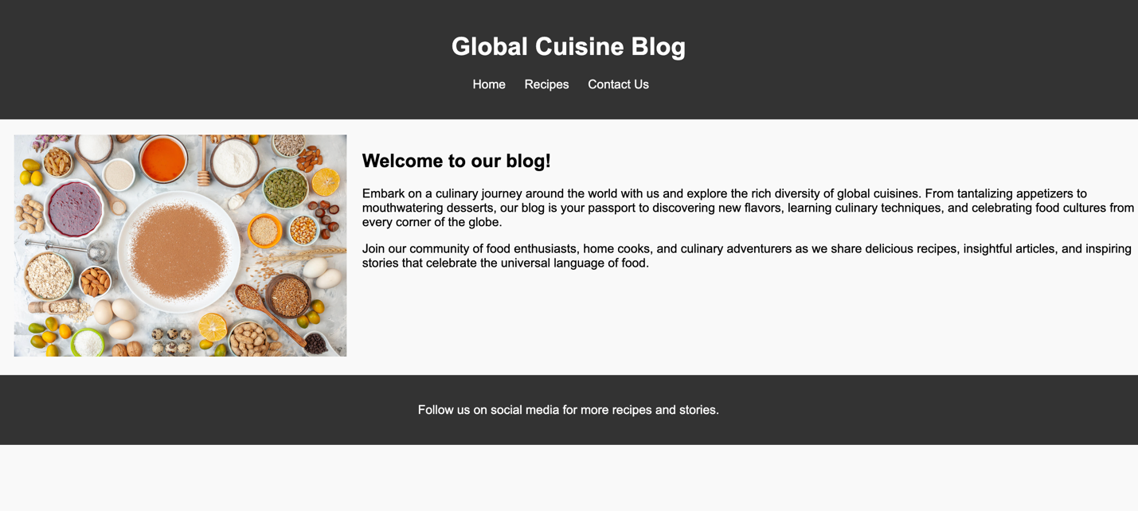
index.html screenshot

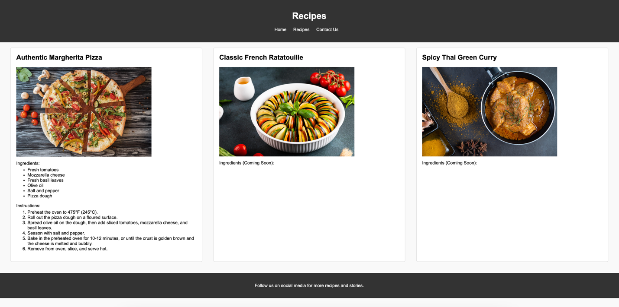
recipes.html screenshot

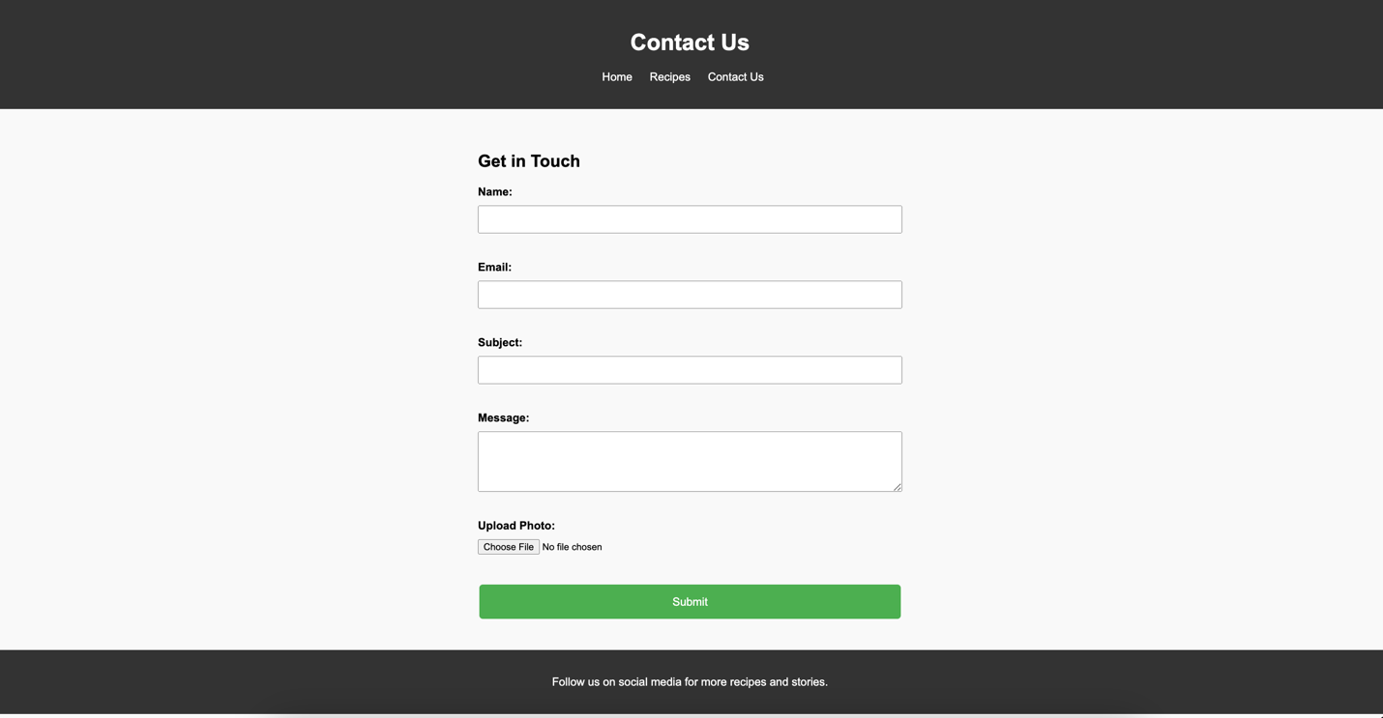
contact.html screenshot

Scoring Items | Points Possible | Points Earned
HTML Structure and Semantics
Effective use of semantic HTML5 tags | 40
Proper nesting and structuring of elements | 30
Use of appropriate tags for content hierarchy | 30
CSS Styling
Effective use of CSS selectors | 50
CSS elements are created and reused on multiple pages | 40
Responsive design for various screen sizes | 40
Functionality and Interactivity
Navigation menu functionality | 30
Form validation on the contact page | 30
Form upload button properly opens file dialog selection window | 30
Accessibility and Compatibility
Compliance with W3C Accessibility Standards | 40
Compatibility testing across different browsers | 30
Implementation of alt attributes for images | 20
Code Quality and Comments
Clean and well-organized code | 40
Consistent indentation and formatting | 30
Clear and concise comments/documentation | 20
Page Design Front-end
index.html renders the same as the screenshot provided | 30
recipes.html renders the same as the screenshot provided | 30
contact.html renders the same as the screenshot provided | 30
Total Points | 350

